

|  |  |  |
| --- | --- | --- |
| BATCH | ENROLLMENT NUMBER | STUDENT NAME |
| B2 | 18103085 | Sudeep Srivastava |
| B7 | 18103236 | Suryansh Singh |
| B9 | 18103281 | Nikhil Chandna |

**Supervisor - Dr. Suma Dawn**

**Minor Project -2**

**Title: WebHealth**

**Computer Science Engineering**

**DEPARTMENT OF COMPUTER SCIENCE ENGINEERING & INFORMATION TECHNOLOGY**

**JAYPEE INSTITUTE OF INFORMATION TECHNOLOGY, NOIDA**

**ACKNOWLEDGEMENT**

This project consumed a huge amount of work, research and dedication. Still, implementation would not have been possible if we did not have support of many individuals, therefore we would like to extend our sincere gratitude to all of them.

We are pleased to acknowledge **Dr.** **Suma Dawn Ma’am** for their invaluable guidance and devoting their time and knowledge in the implementation, during the course of this project work.

My thanks and appreciations also go to my colleagues in developing the project and people who have willingly helped me out with their abilities

## 

## **1. Motivation behind the project.**

In this hectic world Our Personal health gets really messed up therefore as a responsible human we should take care of our body in full earnest .Hence we are developing a project in which we are building a website which will help people to take off their health physically and mentally and help them drive towards their goal. Given that people are looking for cheap Gyms near their locality,Healthy diet, getting proper guidance, and a place or like minded people.

Physical fitness is not the sole basis of being healthy; being healthy means being mentally and emotionally fit. Being healthy should be part of your overall lifestyle. Living a healthy lifestyle can help prevent chronic diseases and long-term illnesses. Feeling good about yourself and taking care of your health are important for your self-esteem and self-image. Maintain a healthy lifestyle by doing what is right for your body.

#### **Maintain a regular exercise routine**

No, you do not have to force yourself into intense workouts at the gym but you need to keep as active as possible. You can stick to easy floor exercises, swimming, walking, or simply keep yourself moving by doing some household chores. Do what your body allows you to do.

What is important is that you continue exercising. Give at least twenty to thirty minutes a day to exercise at least three to five times a week. Have a routine; see to it that you have enough physical activity each day.

#### **Be conscious in your diet**

To maintain a healthy lifestyle, you need to keep eating healthy. Add more fruits and vegetables in your diet and eat less carbohydrates, high sodium and unhealthy fat. Avoid eating junk food and sweets.

Avoid skipping a meal—this will only make your body crave more food the moment you resume eating. Remember to burn more calories than you eat.

## **2. Type of project**

a. Pure development project

We are making a fully functional as well as Responsive Website using MERN Stack.

**3- Analysis of Research Paper and Conclusion Derived**

RESEARCH -1

Thomas, Michael H., and Steve P. Burns. "Increasing lean mass and strength: A comparison of high frequency strength training to lower frequency strength training." *International journal of exercise science* 9.2 (2016): 159.

A research conducted with 7 women and 12 men (*χ̄*= 34.64 years ± 6.91 years).

Half group was assigned to do HFT(High frequency training) based exercises

While the other half was supposed to do LFT(Low frequency training) based exercises with 3 sets per muscle group per session and after 8 week of study they came to the conclusion of which type of training exercise is best for *Lean and Toned body*

The purpose of this investigation was to determine if high frequency agonistic strength training produces greater increases in lean mass and strength compared to lower frequency agonistic strength training, in strength trained participants with both groups completing an equal number of sets.

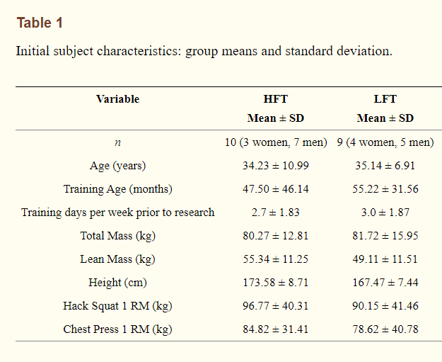

The initial table shows different characteristics of the two groups involved as well as group mean and standard deviation.

The two group followed two different type of exercise regime as mentioned as follows:

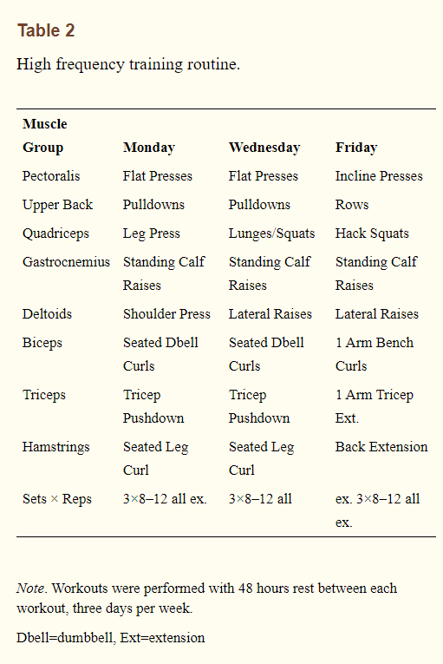

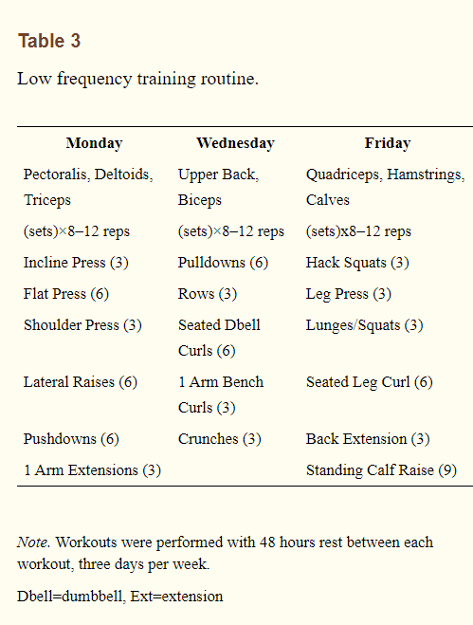

After one to two warm up sets, participants then performed their workout sets. All sets were performed to momentary muscle failure. Repetitions per set were eight-12, equaling a load intensity of ~75–85% of the participant’s 1-RM ([22](https://www.ncbi.nlm.nih.gov/pmc/articles/PMC4836564/#b22-ijes_09_02_159)). Once a participant could perform 12 repetitions with a given resistance, the participant increased the resistance on the following workout by 3%, to the nearest 1.3 kilograms. Repetitions were performed with control during both the eccentric and concentric phases. Both groups rested one to two minutes between sets. Daily workouts lasted ~45–60 minutes and the total training period was eight weeks.

RESULTS:

Mean increase in lean mass for HFT was 1.06 kg ± 1.78 kg and .99 kg ± 1.31kg for LFT, these changes were not significant between groups, *t* ([17](https://www.ncbi.nlm.nih.gov/pmc/articles/PMC4836564/#b17-ijes_09_02_159)) = 0.09, *p* > 0.05, Percent improvements in lean mass was 1.9% for HFT and 2.0% for LFT. There was not a significant effect for changes in lean body mass within groups for HFT, *t* ([9](https://www.ncbi.nlm.nih.gov/pmc/articles/PMC4836564/#b9-ijes_09_02_159)) = 1.89, p>0.05 or LFT*, t* ([9](https://www.ncbi.nlm.nih.gov/pmc/articles/PMC4836564/#b9-ijes_09_02_159)) = − 2.27, p > 0.05.

The lean mass growth for HFT was: 1.06 kg.

for LFT it was: 0.89 kg.

Hence from table 1 we can see that HFT was more effective although not by a big margin.

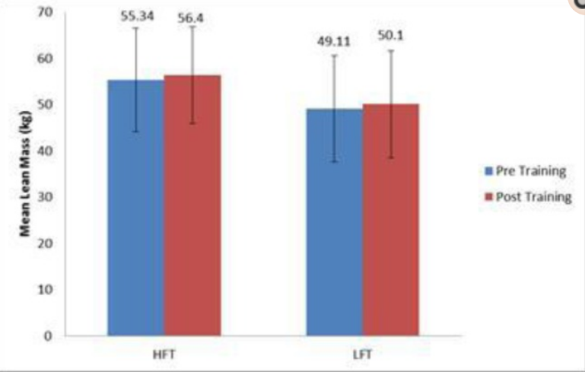

As we can see clearly in the table 2

Mean (kg) strength changes for the chest press 1-RM was 9.07 kg ± 6.33 kg for HFT, and 5.8 kg ± 4.26 kg for LFT. Percent improvement for the chest press 1-RM was 11% for HFT, and 7% for LFT

Whereas Strength changes for the hack squat 1-RM was 20.16 kg ± 11.59 kg for HFT, and 21.83 kg ±11.17 kg for LFT. Percent improvement for the hack squat 1-RM was 21% for HFT, and 24% for LFT

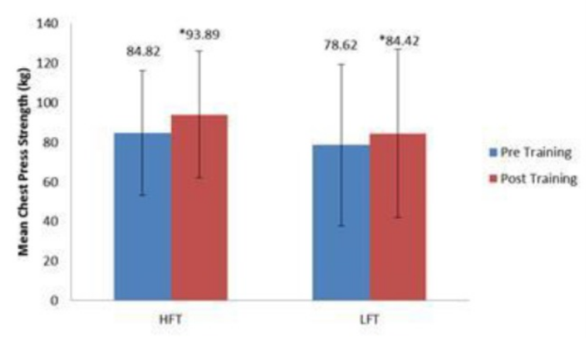

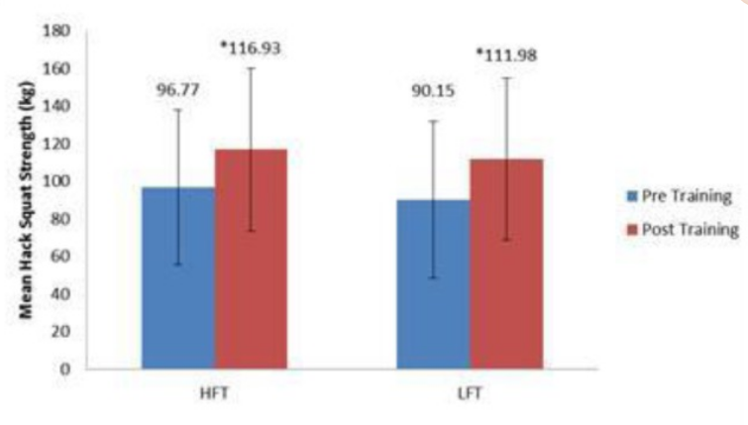

Hence from the above mentioned study, we can clearly observe that HFT shows better results for Lean Mass , strength training and Muscle building.

RESEARCH -2

Boutcher, Stephen H. "High-intensity intermittent exercise and fat loss." *Journal of obesity* 2011 (2011).

Most exercise protocols designed to induce fat loss have focused on regular steady state exercise such as walking and jogging at a moderate intensity. Disappointingly, these kinds of protocols have led to negligible weight loss .Thus, exercise protocols that can be carried out by overweight, inactive individuals that more effectively reduce body fat are required. Accumulating evidence suggests that high-intensity intermittent exercise (HIIE) has the potential to be an economical and effective exercise protocol for reducing fat of overweight individuals.

HIIE protocols have varied considerably but typically involve repeated brief sprinting at an all-out intensity immediately followed by low intensity exercise or rest. The length of both the sprint and recovery periods has varied from 6 s to 4 min. Most commonly the sprints are performed on a stationary cycle ergometer at an intensity in excess of 90% of maximal oxygen uptake(VO2max ). Subjects studied have included adolescents, young men and women, older individuals, and a number of patient groups [[3](https://www.ncbi.nlm.nih.gov/pmc/articles/PMC2991639/#B3)–[12](https://www.ncbi.nlm.nih.gov/pmc/articles/PMC2991639/#B12)]. The most utilized protocol in past research has been the Wingate test which consists of 30 s of all-out sprint with a hard resistance . Subjects typically perform the Wingate test 4 to 6 times separated by 4 min of recovery. This protocol amounts to 3 to 4 min of exercise per session with each session being typically performed 3 times a week for 2 to 6 weeks. Insight into the skeletal muscle adaptation to HIIE has mainly been achieved using this type of exercise [[13](https://www.ncbi.nlm.nih.gov/pmc/articles/PMC2991639/#B13)]; however, as this protocol is extremely hard, subjects have to be highly motivated to tolerate the accompanying discomfiture. Thus, the Wingate protocol is likely to be unsuitable for most overweight, sedentary individuals interested in losing fat. Other less demanding HIIE protocols have also been utilised. For the HIIE Wingate protocols, total exercise time is typically between 3 to 4 min of total exercise per session. Thus, one of the characteristics of HIIE is that it involves markedly lower training volume making it a time-efficient strategy to accrue adaptations and possible health benefits compared to traditional aerobic exercise programs. This review summarises results of research examining the effect of different forms of HIIE on fitness, skeletal muscle, subcutaneous, and abdominal fat loss.

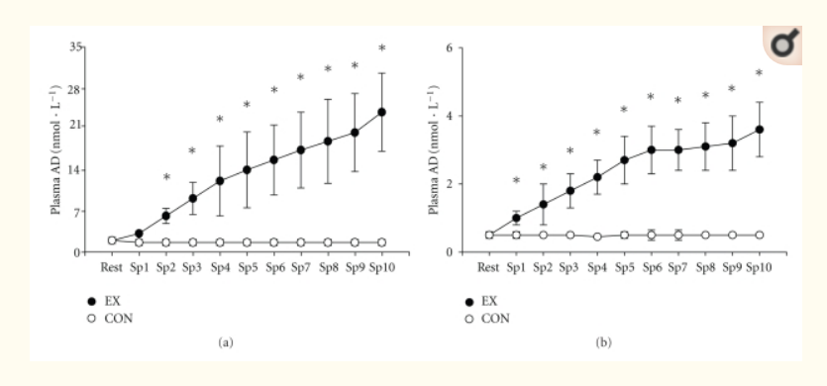

plasma noradrenaline (NA) and adrenaline (AD) concentration of subjects at rest (CON) and following each 6-second sprint (EX) (mean ± SD, *n* = 12).

Nevill examined the growth hormone (GH) response to treadmill sprinting in female and male athletes and showed that there was a marked GH response to only 30 s of maximal exercise and the response was similar for men and women but greater for sprint compared to endurance trained athletes. GH concentration was still ten times higher than baseline levels after 1 hour of recovery. Venous blood cortisol levels have also been shown to significantly increase after repeated 100 m run sprints in trained males, after five 15-second Wingate tests, and during and after brief, all-out sprint exercise in type 1 diabetic individuals .

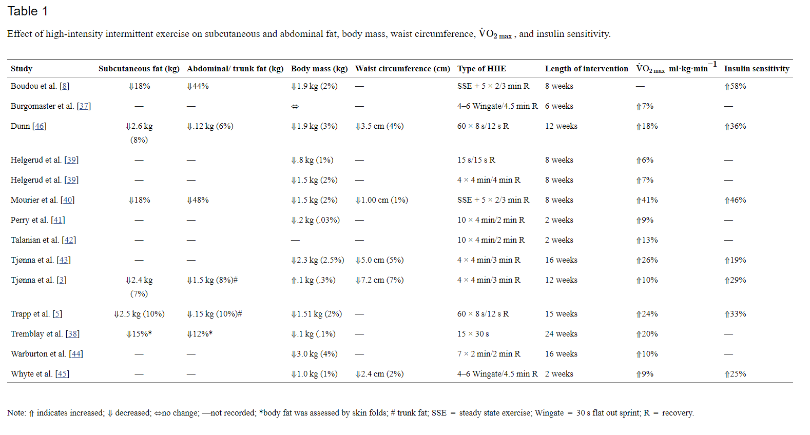

Anaerobic capacity response to HIIE has typically been assessed by measuring blood lactate levels to a standardized exercise load or anaerobic performance on a Wingate test. A number of studies have demonstrated that HIIE lasting from 2 to 15 weeks results in significant increases in anaerobic capacity from between 5% to 28%. For example, Tabata et al. used a 20 s/10 s protocol and found that in previously untrained males, anaerobic capacity, measured by maximal accumulated O2 deficit, was increased by 28%. Whyte et al. carried out a 2-week HIIE intervention and found that previously untrained males increased their anaerobic capacity by 8%, whereas Burgomaster et al. found that Wingate test performance was increased by 5.4% after two weeks of HIIE.

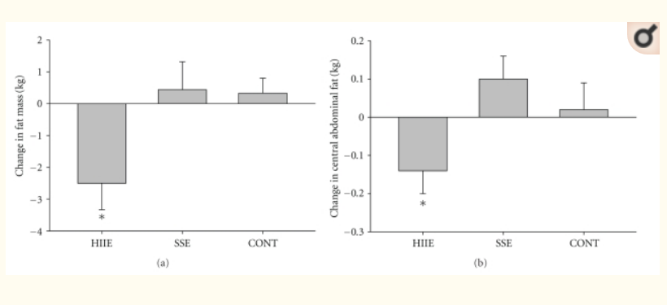

**Subcutaneous (a) and abdominal fat loss (b) after 15 weeks of high-intensity intermittent exercise. HIIE: high-intensity intermittent exercise, SSE: steady state exercise, Cont: control.**

**Research examining the effects of HIIE has produced preliminary evidence to suggest that HIIE can result in modest reductions in subcutaneous and abdominal body fat in young normal weight and slightly overweight males and females. Studies using overweight male and female type 2 diabetic individuals have shown greater reductions in subcutaneous and abdominal fat. The mechanisms underlying the fat reduction induced by HIIE, however, are undetermined but may include HIIE-induced fat oxidation during and after exercise and suppressed appetite. Regular HIIE has been shown to significantly increase both aerobic and anaerobic fitness and HIIE also significantly lowers insulin resistance and results in increases in skeletal muscle capacity for fatty acid oxidation and glycolytic enzyme content.**

## **4. Overall design of project (diagram is welcome)**

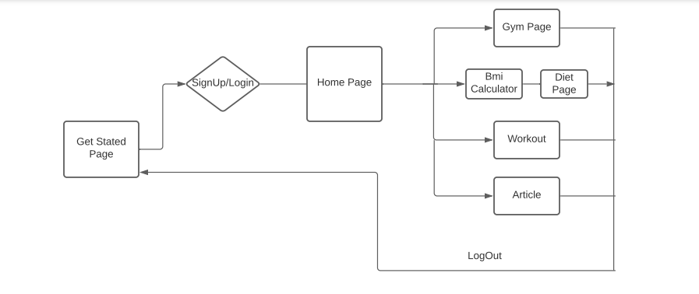

## **5. Features build , language used**

Languages Used:

HTML

JS

CSS

**Technologies Required**:**MERN STACK**

After the four main technologies that make up the stack, MERN stands for MongoDB, Express, React, and Node.

● MongoDB is a document database system.

● Node.js application system Express(.js).

● React(.js) is a JavaScript client-side framework.

● The most common JavaScript web server is Node(.js). MERN

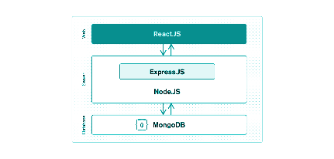

**Is MERN a complete solution?**

Yes, MERN is a full-stack framework, with the front-end display tier (React.js), application tier (Express.js and Node.js), and database tier all following the standard 3-tier architectural pattern (MongoDB)

Why choose the MERN stack?

MongoDB integrates seamlessly with Node.js, making storing, manipulating, and representing JSON data at all levels of your application a breeze. MongoDB Atlas makes it even simpler for cloud-native applications by providing an auto-scaling MongoDB cluster on the cloud provider of your choosing with only a few button clicks.

The JavaScript/JSON programme MERN's full stack is made up of Express.js (running on Node.js) and React.js. Express.js is a server-side application framework for wrapping HTTP requests and responses and making mapping URLs to server-side functions easy.

React.js is a JavaScript frontend application for creating interactive HTML user interfaces that communicate with a remote server.

JSON data flows naturally from front to back as a result of this combination, making it quick to develop and debug. Plus, to understand the entire scheme, you just need to know one programming language and the JSON document structure!

MERN is the go-to stack for today's web developers who want to get things done quickly, particularly those who have worked with React.js.

## **6. Algorithm/Description of the Work**

Our website is a complete solution for a person who wanna enhance their physical health.

HOMEPAGE-

The user is greeted with a Responsive homepage with access to the login page as well as a video explaining them about our website .

SIGN-UP/LOG-IN

A user then logins or signups into the system with a username/email and password which is stored in the MongoDB Database.

WELCOME PAGE

User is redirected to a welcome page where there is a chatbot along with a sidebar and all the sub-links connected to different pages.User can see their name on the top right corner depicting that they have logged in.

CHATBOT-

We have used an API called Kommunicate which is an AI-Powered and trainable bot along with the ability to connect users to a human agent.

SIDEBAR-

Through Sidebar a user can navigate through different pages on our website as per their requirement.

GYM-

Through the Gym link user can visit and see different gyms in their area as well as can see various details of gym or track their location on Google map

WORKOUT-

First we will understand a user’s needs and then suggest them workouts according to their needs.

A user needs to input their gender, age,and what they wanna achieve and with the help of various research papers we studied we will suggest them the best routine to follow for their health.

BMI CALCULATOR AND DIETS-

A user needs to enter their age ,gender , physical activity,height and weight with which we will calculate BMI using the standard formula -

BMI= (weight)/(height*height)

And then depending if the user wanna see the best suggested diet for them we will ask them to continue and suggest the best diet according to their calorie needs by using Harris-Benedict formula.

Formula used to calculate men’s calorie needs is = 66.5 + 13.8 x (body weight in kilograms) + 5 x (body height in cm) divided by 6.8 x age. Meanwhile for women= 655.1 + 9.6 x (body weight in kilograms) + 1.9 x (body height in cm) divided by 4.7 x age.

ARTICLE-

A user will see various articles that we have linked through guiding them to the various websites where we can read the Article as well as a newsletter and subscribe to the website.

## **7. Results and Conclusion**

Our website successfully recommends an appropriate caloric diet as well as suggest a good workout routine along with local nearby places where they can go exercise. Also, an assisted chatbot is added to guide them.

Gyms:

Our website can be used to find different gyms. Users also have the option to add gyms themselves. This facilitates community building and encourages users to come together to help others.

Diets

Our website also has a diet section where users will be recommended different diets based on their BMI, age, and gender. Having the right diet makes a substantial difference to our overall health and well being. It protects you against many chronic noncommunicable diseases, such as heart disease, diabetes and cancer. Eating a variety of foods and consuming less salt, sugars and saturated and industrially-produced trans-fats, are essential for a healthy diet.

Workout

We also have a section for different workout regimes to search from. Users can look for their workout regime and select the right one according to their goals. Exercising has numerous benefits from improving mood and sleep etc. It is also scientifically proven to reduce all cause mortality

Article

There is also a section of articles where users can add different articles to let each other know about whatever is new happening in the fitness industry. Any kind of new breathing techniques or anything at all which promotes better well being are welcome here.

Chatbot

We also have an assisted chatbot which users can use to find the right thing they need on the website. Often, some people find it difficult to navigate websites so a chatbot can be used in this case. If the query seems complicated for a chatbot, then a live human can take over and answer queries.

**REFERENCES**

**1. Candow D, Burke D. Effect of short-term equal-volume resistance training with different workout frequency on muscle mass and strength in untrained men and women. *J Strength Cond Res.* 2007;21(1):204–207. [**[**PubMed**](https://www.ncbi.nlm.nih.gov/pubmed/17313289)**] [**[**Google Scholar**](https://scholar.google.com/scholar_lookup?journal=J+Strength+Cond+Res&title=Effect+of+short-term+equal-volume+resistance+training+with+different+workout+frequency+on+muscle+mass+and+strength+in+untrained+men+and+women&author=D+Candow&author=D+Burke&volume=21&issue=1&publication_year=2007&pages=204-207&pmid=17313289&)**]**

**2. Carpinelli R, Otto R, Winnett R. A critical analysis of the ACSM position stand on resistance training: Insufficient evidence to support recommended training protocols. *J Exerc Physiol Online.* 2004;7(3):1–60. [**[**Google Scholar**](https://scholar.google.com/scholar_lookup?journal=J+Exerc+Physiol+Online&title=A+critical+analysis+of+the+ACSM+position+stand+on+resistance+training:+Insufficient+evidence+to+support+recommended+training+protocols&author=R+Carpinelli&author=R+Otto&author=R+Winnett&volume=7&issue=3&publication_year=2004&pages=1-60&)**]**

**3. Difrancesco-Donoghue J, Werner W, Douris P. Comparison of once-weekly and twice-weekly strength training in older adults. *Br J Sports Med.* 2007;41(1):19–22. [**[**PMC free article**](https://www.ncbi.nlm.nih.gov/pmc/articles/PMC2465144/)**] [**[**PubMed**](https://www.ncbi.nlm.nih.gov/pubmed/17062657)**] [**[**Google Scholar**](https://scholar.google.com/scholar_lookup?journal=Br+J+Sports+Med&title=Comparison+of+once-weekly+and+twice-weekly+strength+training+in+older+adults&author=J+Difrancisco-Donoghue&author=W+Werner&author=P+Douris&volume=41&issue=1&publication_year=2007&pages=19-22&pmid=17062657&)**]**

**4. Shaw K, Gennet H, O’Rourke P, Del Mar C. *Exercise for Overweight or Obesity.* John Wiley & Sons; 2006. The Cochrane Collaboration. [**[**Google Scholar**](https://scholar.google.com/scholar_lookup?title=Exercise+for+Overweight+or+Obesity&author=K+Shaw&author=H+Gennet&author=P+O%E2%80%99Rourke&author=C+Del+Mar&publication_year=2006&)**]**

**5. Wu T, Gao X, Chen M, Van Dam RM. Long-term effectiveness of diet-plus-exercise interventions vs. diet-only interventions for weight loss: a meta-analysis: obesity Management. *Obesity Reviews.* 2009;10(3):313–323. [**[**PubMed**](https://www.ncbi.nlm.nih.gov/pubmed/19175510)**] [**[**Google Scholar**](https://scholar.google.com/scholar_lookup?journal=Obesity+Reviews&title=Long-term+effectiveness+of+diet-plus-exercise+interventions+vs.+diet-only+interventions+for+weight+loss:+a+meta-analysis:+obesity+Management&author=T+Wu&author=X+Gao&author=M+Chen&author=RM+Van+Dam&volume=10&issue=3&publication_year=2009&pages=313-323&pmid=19175510&)**]**

**6. Tjønna AE, Stølen TO, Bye A, et al. Aerobic interval training reduces cardiovascular risk factors more than a multitreatment approach in overweight adolescents. *Clinical Science.* 2009;116(4):317–326. [**[**PubMed**](https://www.ncbi.nlm.nih.gov/pubmed/18673303)**] [**[**Google Scholar**](https://scholar.google.com/scholar_lookup?journal=Clinical+Science&title=Aerobic+interval+training+reduces+cardiovascular+risk+factors+more+than+a+multitreatment+approach+in+overweight+adolescents&author=AE+Tj%C3%B8nna&author=TO+St%C3%B8len&author=A+Bye&volume=116&issue=4&publication_year=2009&pages=317-326&pmid=18673303&)**]**

**7. Trapp EG, Chisholm DJ, Freund J, Boutcher SH. The effects of high-intensity intermittent exercise training on fat loss and fasting insulin levels of young women. *International Journal of Obesity.* 2008;32(4):684–691. [**[**PubMed**](https://www.ncbi.nlm.nih.gov/pubmed/18197184)**] [**[**Google Scholar**](https://scholar.google.com/scholar_lookup?journal=International+Journal+of+Obesity&title=The+effects+of+high-intensity+intermittent+exercise+training+on+fat+loss+and+fasting+insulin+levels+of+young+women&author=EG+Trapp&author=DJ+Chisholm&author=J+Freund&author=SH+Boutcher&volume=32&issue=4&publication_year=2008&pages=684-691&pmid=18197184&)**]**

**8. Buchheit M, Laursen PB, Ahmaidi S. Parasympathetic reactivation after repeated sprint exercise. *American Journal of Physiology.* 2007;293(1):H133–H141. [**[**PubMed**](https://www.ncbi.nlm.nih.gov/pubmed/17337589)**] [**[**Google Scholar**](https://scholar.google.com/scholar_lookup?journal=American+Journal+of+Physiology&title=Parasympathetic+reactivation+after+repeated+sprint+exercise&author=M+Buchheit&author=PB+Laursen&author=S+Ahmaidi&volume=293&issue=1&publication_year=2007&pages=H133-H141&pmid=17337589&)**]**

**9.Boutcher, Stephen H. "High-intensity intermittent exercise and fat loss." *Journal of obesity* 2011 (2011).**

**10.https://reactjs.org/tutorial/tutorial.html**

**11.**[**https://ieeexplore.ieee.org/document/7148104**](https://ieeexplore.ieee.org/document/7148104)

**12.https://cssreference.io/**